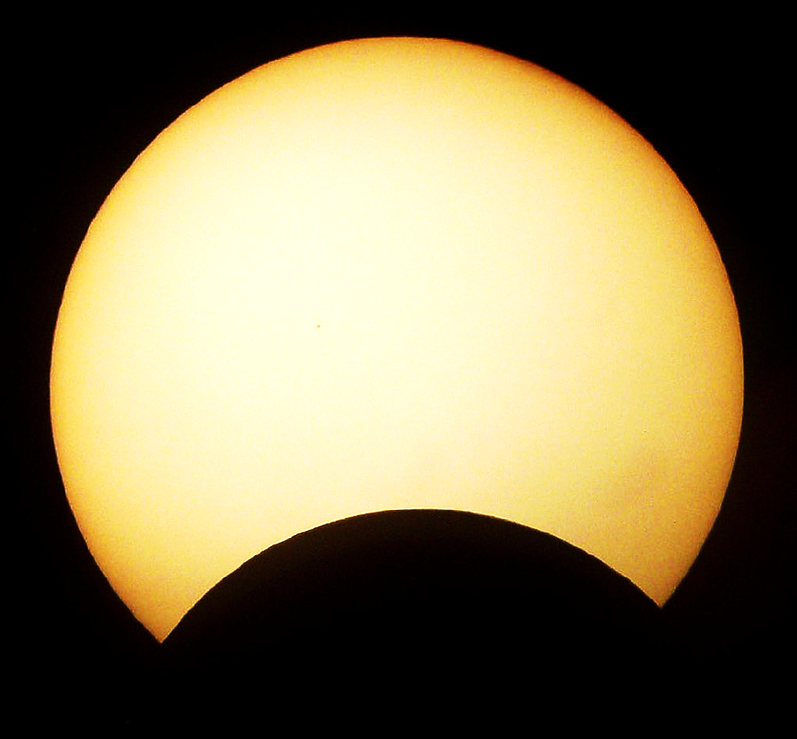
Partial Solar Eclipse
Viewing Party

Where: Grand Haven City Beach
When: Thursday, October 23rd, 5:30pm

Presented by:
White Pines
Intermediate School
Planetarium

